Sofia
Sofia is the capital of Bulgaria. There are many landmarks. It is a large administrative center. Sofia has a typical European oceanic climate. Summers are warm, at times hot. The warmest months are July and August to 25 °C - 28 °C through the day.
It is situated in western Bulgaria, at the northern foot of the Vitosha Mountain. With a history that stretches over seven millennia, ruin-rich Sofia is one of Europe's oldest cities. The National Historical Museum is one of Eastern Europe's most extensive. Wide, cobblestone boulevards, charming boutiques and truly electrifying nightlife star in this city of 2.0 million. New modern subway, trolleys, trams and buses traverse in city.

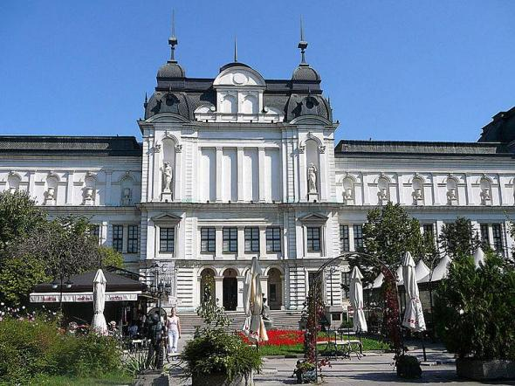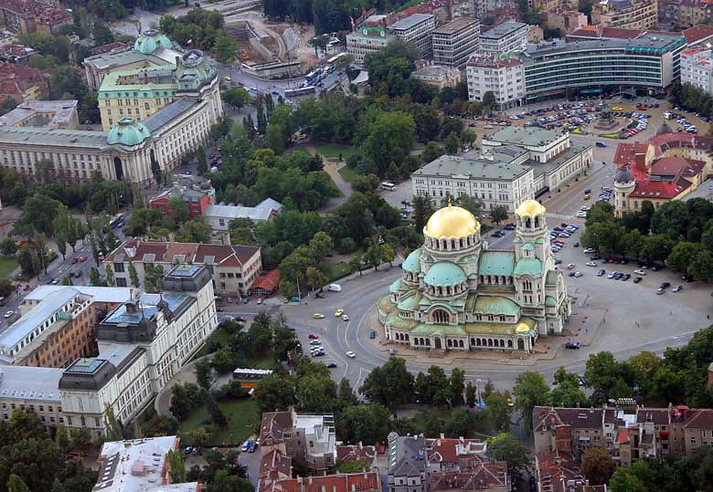

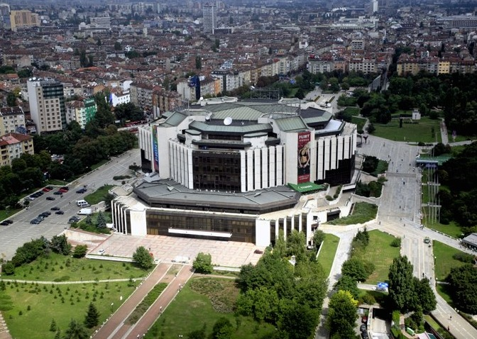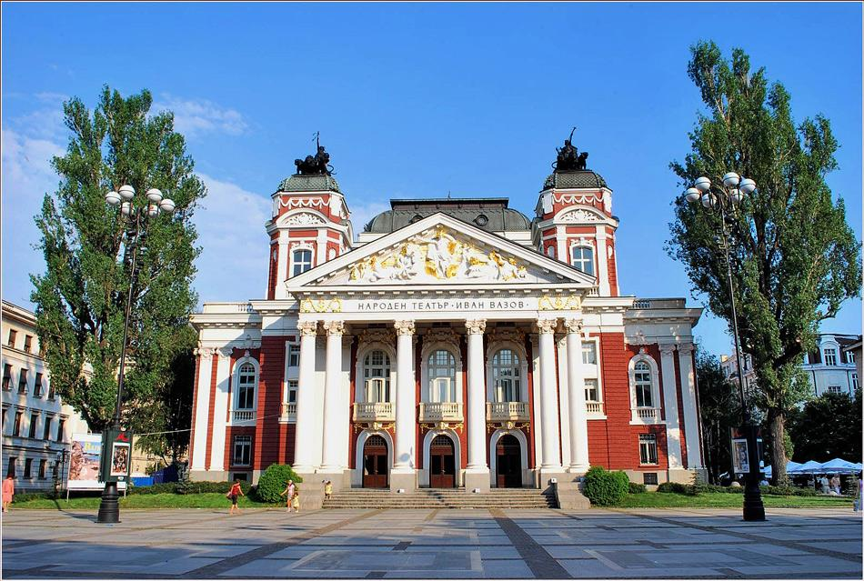

Dojo Address: 1172, Sofia, 1 Nikola Gabrovski Str. The area of ​​the mat professional tatami is 620m2 with air conditioning.
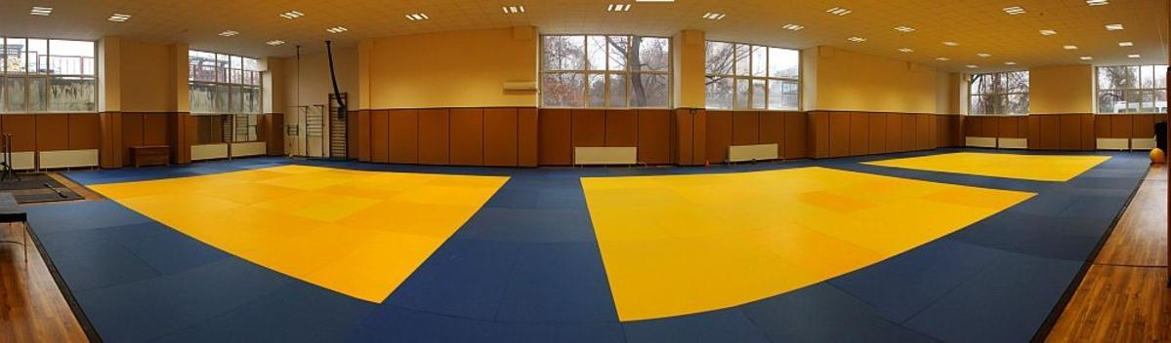

Hotel
We offer a special package price, only for participants with prior application participation for a summer camp in Sofia on a beautiful, quiet hotel just 5 minutes from the dojo. The hotel offers a rich breakfast, central air conditioning, luxurious bathrooms.
Price:
1) Room with 2 SEPARETE beds for 2 people 7 nights (Breakfast is included)
€ 349.00 incl taxes
2) Room with large terrace with view Vitosha Mountain with 2 SEPARETE beds for 2 people 7 nights (Breakfast is included)
€ 378.00 incl taxes
3) Room with 3 SEPARETE beds for 3 people 7 nights (Breakfast is included)
€ 414.00 incl taxes
4) Room for one person for 7 night (Breakfast is included)
€ 245.00 incl taxes

http://www.hotel-latinka-sofia.com/

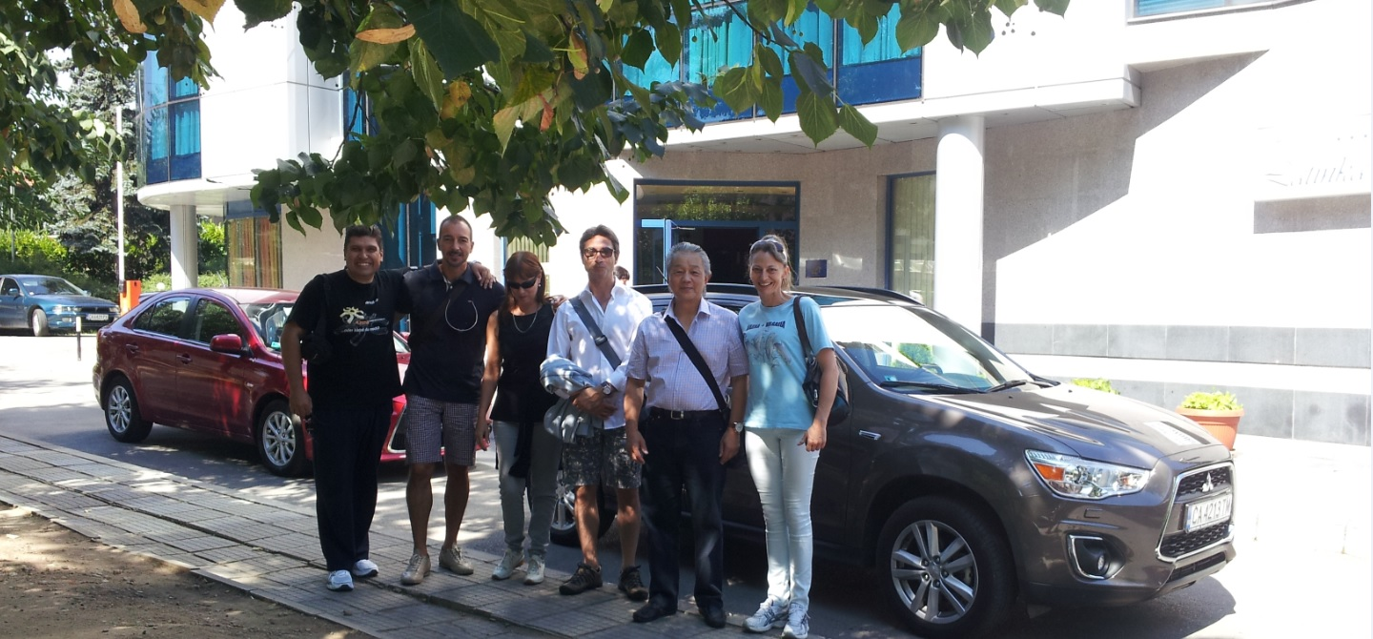

Pay: You will pay the price of the hotel when you arrive in Bulgaria. It is possible to pay by credit card at the hotel reception. Please, contact us two months before your arrival, to keep rooms at the hotel.

Additional program - visits of the RIU Pravets Resort, landmarks capital Sofia and visit Vitosha Mountain.

Restaurant
There are a variety of restaurants offering Bulgarian, European and Asian food. Meal will be mainly in Brick Restaurant, Este Restaurant, Happy Bar & Grill and Villa Victoria which is near the hotel. A wide variety of lunch and dinner cost only 7-8 euros per rich meal.

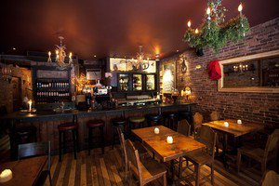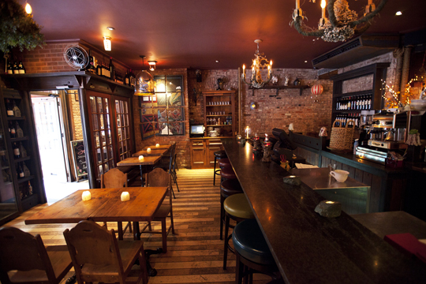

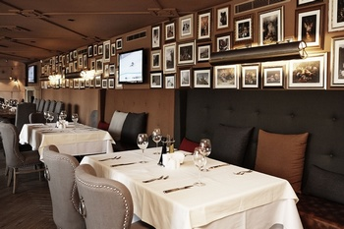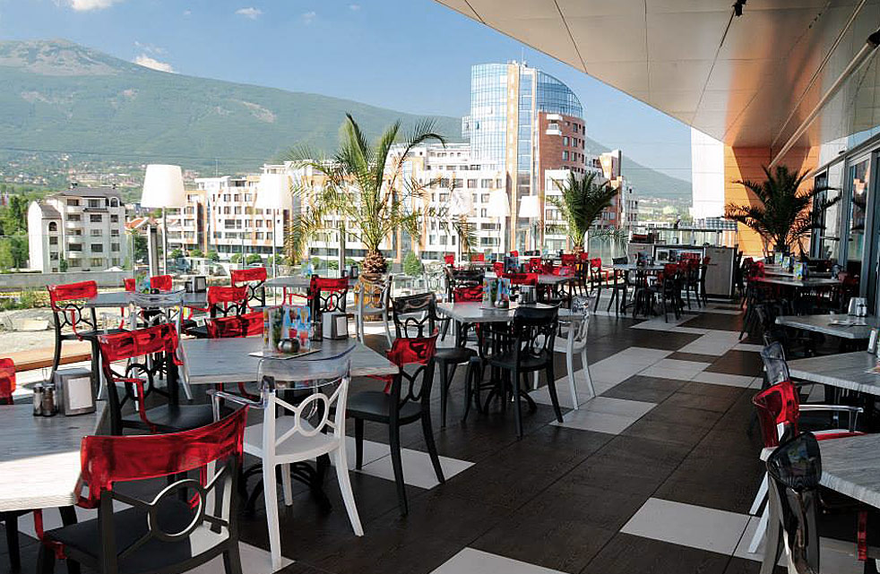

Arriving by plane:
Sofia Airport (we provide free transport for all periods of summer camp with our cars).

E-mail for contact:
takemusuaiki@mail.bg
aikidotakemusu@abv.bg
Website: http://takemusuaiki.bg/
Tel: +359888268212
Svetozar Angelov

